EXPERIMENT 1:
import java.util.Scanner;
class MatrixOperation {
void read(int X[][], Scanner sc) {
int R = X.length;
int C = X[0].length;
for (int i = 0; i < R; i++) {
for (int j = 0; j < C; j++) {
X[i][j] = sc.nextInt();
}
}
}
void display(int X[][]) {
int R = X.length;
int C = X[0].length;
for (int i = 0; i < R; i++) {
for (int j = 0; j < C; j++) {
System.out.print(X[i][j] + "\t");
}
System.out.println();
}
}
}
public class Matrix {
public static void main(String args[]) {
Scanner sc = new Scanner(System.in);
MatrixOperation ob = new MatrixOperation();
System.out.println("Enter the number of rows: ");
int rows = sc.nextInt();
System.out.println("Enter the number of columns: ");
int cols = sc.nextInt();
int A[][] = new int[rows][cols];
int B[][] = new int[rows][cols];
System.out.println("Enter Matrix A: ");
ob.read(A, sc);
System.out.println("Enter Matrix B: ");
ob.read(B, sc); // Pass the scanner object
System.out.println("Matrix A: ");
ob.display(A);
System.out.println("Matrix B: ");
ob.display(B);
sc.close();
}
}

OUTPUT:
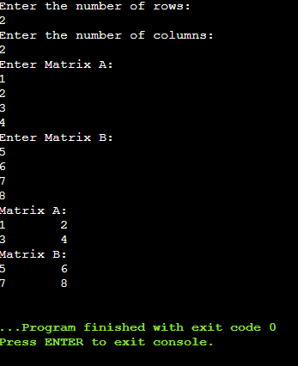
EXPERIMENT 2:
import java.util.Scanner;
public class Exp2{
public static void main(String args[]) {
Scanner sc=new Scanner(System.in);
String str1;
String str2;
System.out.println("Enter the String: ");
str1=sc.nextLine();
str2=sc.nextLine();
System.out.println("String 1 is: "+str1);
System.out.println("String 2 is: "+str2);
int a=str2.length();
System.out.println("Length of string a is: "+a);
String str3=str1.concat(str2);
System.out.println("String 3 is: "+str3);
sc.close();
}
}

OUTPUT:
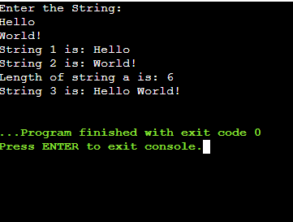
EXPERIMENT 3:
import java.util.Scanner;
class Box
{
double depth;
double width;
double height;
Box(double d)
{
depth =width =height = d;
}
void volume()
{
double V= depth * width *height;
System.out.println("Volume:" + V);
}
}
class Boxweight extends Box
{
double weight;
Boxweight(double d, double x)
{
super(d); //call superclass constructor
weight = x;
}
void show()
{
System.out.println("Weight:" + weight);
}
}
class Boxcost extends Boxweight
{
double cost;
Boxcost(double d, double x, double c)
{
super(d, x);
cost = c;
}
void show()
{
super.show(); //weight
System.out.println("Cost is:" + cost);
}
}
class Inh
{
public static void main(String[] args)
{
Boxcost ob =new Boxcost(7.5,50.5,30.5);
ob.volume();
ob.show();
}
}

OUTPUT:
